H.T No
Regulations:
A20

Sreenidhi Institute of Science and Technology
(An Autonomous Institution)
Code No: 8A304 Date: 08-Aug-2023 (FN)

B.Tech II-Year I- Semester External Examination, Aug - 2023 (Supplementary)
ELECTRICAL CIRCUITS AND NETWORKS – II (EEE)

Time: 3 Hours Max.Marks:70

Note: a) No additional answer sheets will be provided.
b) All sub-parts of a question must be answered at one place only, otherwise it will not be valued.
c) Missing data can be assumed suitably.

Bloom's Cognitive Levels of Learning (BCLL)

Remember | L1 | Apply | L3 | Evaluate | L5
Understand | L2 | Analyze | L4 | Create | L6

Part - A Max.Marks:20
Answer all QUESTIONS

 |  | BCLL | CO(s) | Marks
1 | Three loads, each of resistance 30, are connected in star to a 415 V, 3-phase supply. Determine the system phase voltage. | L5 | CO1 | [2M]
2 | Write the expression for critical resistance and damping ratio of RLC series circuit. | L1 | CO2 | [2M]
3 | Find the DC Gain of the function H(s)=20(s+2)/(s²+2s+5) | L3 | CO3 | [2M]
4 | What is two port network? | L1 | CO4 | [2M]
5 | What are the Applications of Filter? | L1 | CO5 | [2M]
6 | Explain periodic function with example? | L2 | CO6 | [2M]
7 | Write the expression for the instantaneous values of emfs in a 3 phase circuit. | L1 | CO1 | [2M]
8 | What is reciprocal network? | L1 | CO4 | [2M]
9 | If a system has a voltage gain of 40 dB, find the applied voltage if the output voltage is 7V. | L3 | CO6 | [2M]
10 | Explain the concept of complex frequency? | L6 | CO3 | [2M]
Part – B Max.Marks:50
ANSWER ANY FIVE QUESTIONS. EACH QUESTION CARRIES 10 MARKS.

 |  |  | BCLL | CO(s) | Marks
11. | a) | Derive the relation between a line current and phase current and a line voltage and a phase voltage related to delta connected load? | L5 | CO1 | [5M]
 | b) | Two wattmeters are connected to measure the input power to a balanced 3-phase load by the two-wattmeter method. If the instrument readings are 8kW and 4kW,  find (i) the total power input and (ii) the load power factor. | L3 | CO1 | [5M]
12. | a) | Derive the expression for transient response of series R-L circuit driven by sinusoidal excitation by using Laplace transform method? | L5 | CO2 | [5M]
 | b) | In the circuit shown below find out the expressions for the current i1 and i2 when the switch is closed at time t= 0  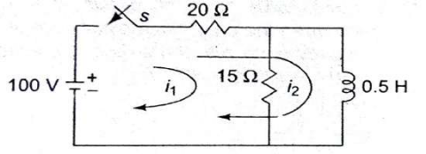 | L3 | CO2 | [5M]
13. | a) | Obtain the transform impedance of an inductor? | L3 | CO3 | [5M]
 | b) | Compute the driving point impedance of the network in fig.  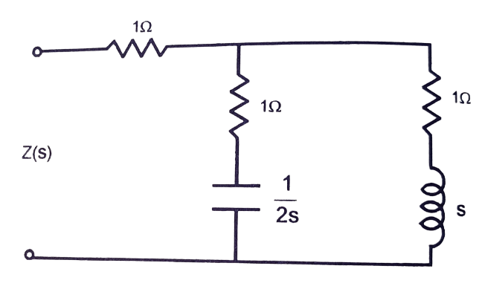 | L2 | CO3 | [5M]
14. | a) | Determine the admittance parameters of the T network shown in Fig.  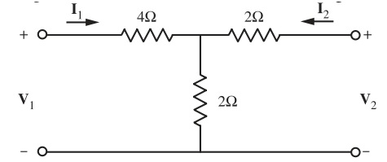 | L5 | CO4 | [5M]
 | b) | Discuss the condition of Symmetry in Y-Parameter representation? | L2 | CO4 | [5M]
15. | a) | Explain the classification of pass band and stop band in detail. | L6 | CO5 | [5M]
 | b) | Obtain the values of L and C for a prototype low pass filter with R₀=500 ohm and cut off frequency f_{c}=2kHz. | L3 | CO5 | [5M]
16. | a) | List out the fourier transform properties? | L6 | CO6 | [5M]
 | b) | Explain in brief concept of even and odd functions? | L2 | CO6 | [5M]
17. | a) | List any four advantages of 3-phase system over 1-phase system? | L6 | CO1 | [4M]
 | b) | Explain over damped response of series RLC circuit for DC excitation? | L2 | CO2 | [3M]
 | c) | What are the properties of transfer function? | L1 | CO3 | [3M]
18. | a) | Express Z-parameters in terms of h-parameters. | L5 | CO4 | [4M]
 | b) | What is a filter? Explain about various types of filters. | L1 | CO5 | [3M]
 | c) | Calculate a₀ for the following (i) 4 sin4t (ii) 4 cos4t | L3 | CO6 | [3M]

-- 00 -- 00 –

